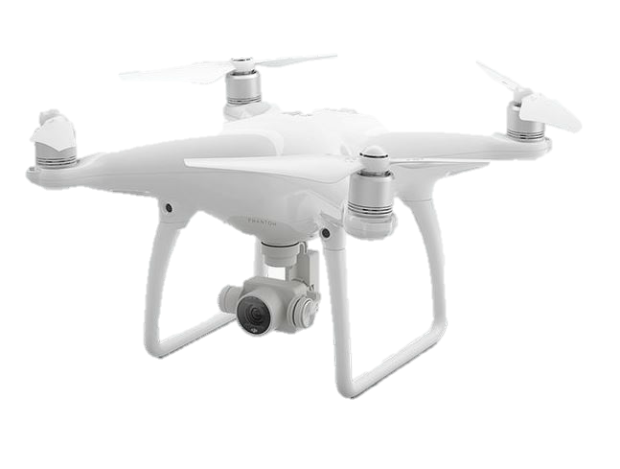
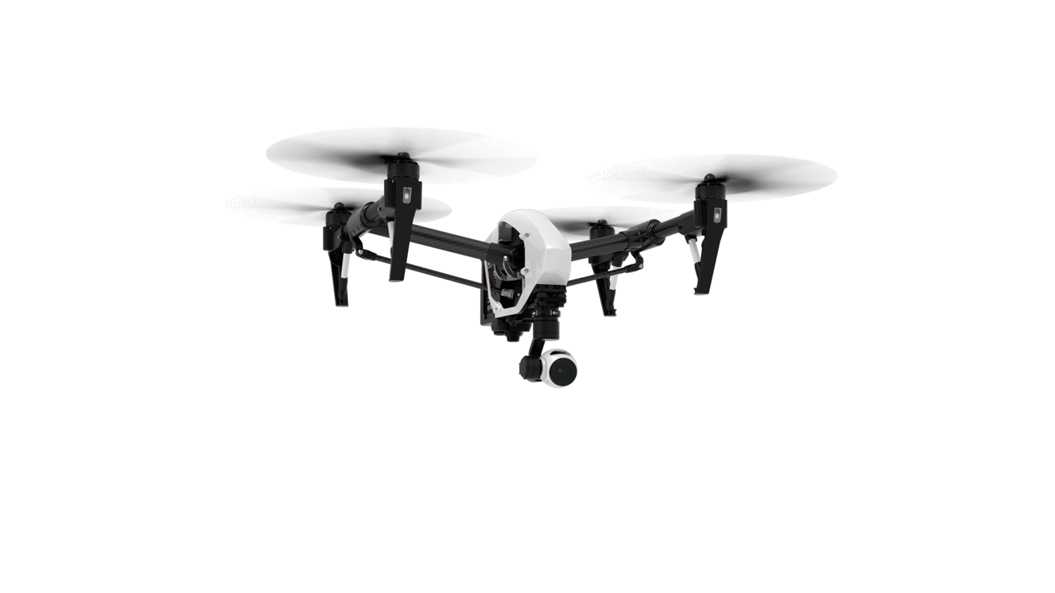
DJI New Pilot Experience
Key Takeaways

Phantom 4 Pro/Inspire 2 Key features
- Provides everything RTF out of the box, including 16GB SD card.
- Easy to operate with precision flight and stable hovering using dual IMU’s
- Built in Return to home, Intelligent Flight Modes, & No Fly Zones safety features
- High performance 4K/5.2K camera
- 3-axis camera stabilization
- Camera tilt control from -30 to 90 degrees
Phantom 4 Pro/Inspire 2 FAQs
Flight Time？ | P4 Pro Up to 30min/I2 up to 27min
Flight Range？ | Up to 4.3 Miles (FCC Compliant)
Service Ceiling | Aprox. 19,000 ft.
How fast it flies？ | P4 Pro= 45mph; I2 = 58mph
Takeoff weight？ | P4 Pro = 3lbs; I2 = 8.8lbs
Camera quality? | P4 Pro = 16MP/ UHD4K@60p/FHD@120p; 100mbps  I2 w/X4S = 16MP C4K@60p/FHD@120p; 100mbps  I2 w/X5S = 20.8MP/C-DNG Raw or ProRes 5.2K@30p; 4.2gbps

How to fly Phantom 4 Pro/Inspire 2？
- Get ready & Pre-Flight Checklist
  - Propellers and Gimbal free of obstruction check
  - Turn on the remote controller
  - Open DJI GO 4 App
  - Turn on UAV
  - Battery Status Check (50%+)
  - Micro SD/SSD card space

- Calibration
  - Calibrate the Compass (if changing time of day, or departure location)
  - LED flight indicator to flashing Green, home point recorded
  - Verify 7+ satellite connections for proper GPS accuracy.
  - Ready to take off

- Motor Startup
  - Push both sticks down and inwards; release the sticks once the motors spin up. Or initiate Auto-Takeoff
  - Push the throttle stick upward slowly beyond the neutral position to take off
  - Monitor UAV, stay in appropriate height and direction, always maintaining visual contact.
  - Create cinematic graceful shots simply by clicking the record/shutter buttons on Radio TX

- Mission Completed
  - Land the aircraft softly. Or initiate Auto-Land
  - Turn off the aircraft by holding just the throttle stick down 3 seconds if Auto-Land was not initiated
  - Power off UAV via battery power switch
  - Turn off the remote controller
  - Synchronize album with smart device and share to them to social media.

Pre-Flight To Do’s:
- Check www.KnowBeforeYouFly.org
- Pre-flight weather check www.uavforecast.com
- Flying area check and recommendation:
  - Open and unobstructed
  - Areas with no magnetic interferences
- Compass calibration and home point record.
- Stay focused while flying, with no distractions.
- Be aware of the flight parameters, TFR’s, no fly zones, and other restricted airspace’s
- Periodically check IMU sensors are within airworthiness parameters

Phantom 4/ Inspire 1 Maintenance Notes:
- Keep away from magnetic objects and water
- Store Phantom in a cool and dry place
- Store LiPo batteries under 40% for long term (10+ days)
- Keep propellers in good conditions

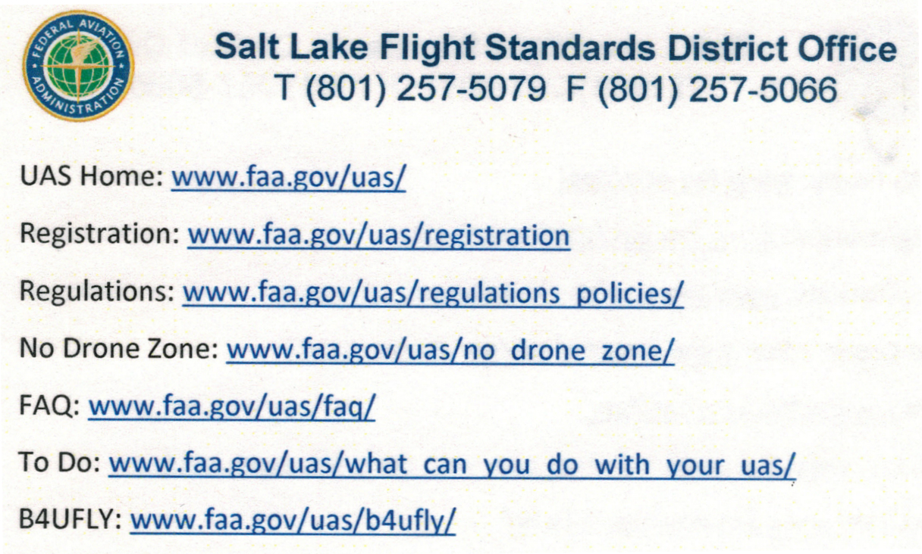

*For additional instructions visit, www.youtube.com/user/TVSpecialists

